**DSA Lab Task 12 (1, 2)**

Name: **Waseem Arshad**

**Roll No: 052**

Dept: **Softwares Engineering**

**Submitted to:** Pro. Rasikh Ali

**BST**

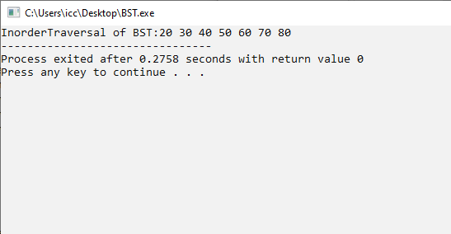

**AVL**

